**ICA 8.6 Entity Relationship example (Football club)**

**Jeremey Donovan - jdd5dw**

**Diana McSpadden hdm5s**

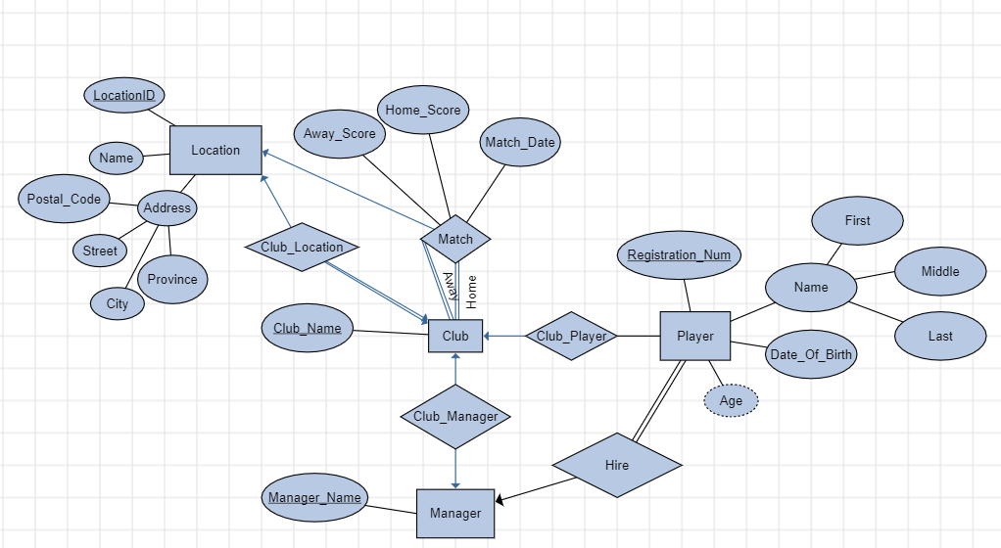

**Schemas**

**Location** (LocationID, Name, Street_Address, City_Address, Province_Address, Postal_Code_Address)

**Club (**Club_Name, Manager_Name)

**Manager** (Manager_Name)

**Player (**Registration_Num, Date_Of_Birth, First_Name, Middle_Name, Last_Name)

**Club_Player**(Club_Name, Registration_Num)

**Match**(Away_Club_Name, Home_Club_Name, Match_Date, Home_Score, Away_Score)

**Club_Location**(Club_Name, Location_ID)

**Hire**(Manager_Name, Registration_Num)

We did not make Player a weak entity, or hire a weak relationship because players can exist in a draft before they are hired by a manager.